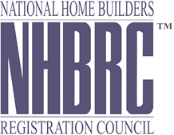

Bid No: 1111/2013
DESCRIPTION OF SERVICE: DATA CLEANISING SERVICES
Number | Name of Service Provider | Amount
1 | Neo Solutions | R 4 963 834.00
2 | Deloitte & Touche | R 4 629 708.72
3 | BNG ( Buleng systems & technology) | R 5 510 398.98
4 | Cornerstone Technology | R 5 387 640.00
5 | Khusela Business Intelligence technologies | R 8 316 509.76
6 | Acutech Business Solutions | R 1 553 261.40
7 | Skhomo Technologies | R 3 632 314.00
8 | Zandile Management services | R11 per account
9 | Sizwe Ntsaluba Godobo advisory | R 9 751 600.00
10 | EOH Mthombo (pty) ltd | R 13 783 854.00
11 | EPI-USE Africa (pty) ltd | R 9 093 967.00
TOTAL BIDS RECEIVED eleven(11)

