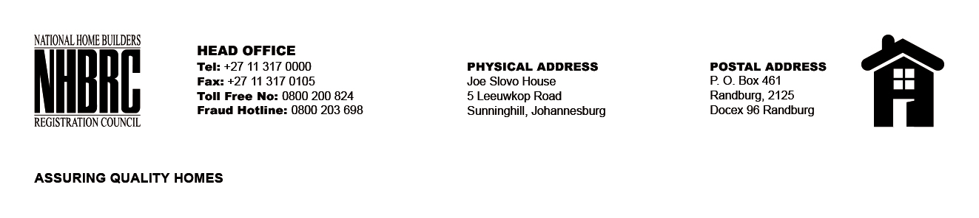

BID NUMBER: NHBRC 02/2015 – CLOSING DATE: 23 FEBRUARY 2015

APPOINTMENT OF A SUITABLE SERVICE PROVIDER TO COMPLETE A FUTURE/ FORESIGHT STUDY ON THE HOME BUILDING INDUSTRY.
NO. | NAME OF BIDDER
1. | Matlotlo Group (Pty) Ltd
TOTAL: 01

