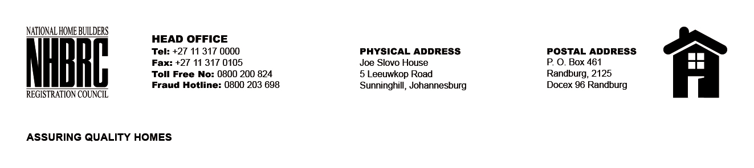

BID NUMBER: NHBRC 03/2015 – CLOSING DATE: 24 FEBRUARY 2015

APPOINTMENT OF A SERVICE PROVIDER FOR THE DESIGN, DEVELOP AND IMPLEMENTATION OF THE HOME QUALITY ASSURANCE SYSTEM (HOMQUAS)
NO. | NAME OF BIDDER
1. | Xcallibre (Pty) Ltd
2. | EIN Technology Solutions (Pty) Ltd
3. | Vuka Business Consultants
4. | MDP Consulting CC
5. | Zimele ERP IT Services (Pty) Ltd
6. | Archibus Solutions Centre South Africa (Pty) Ltd
7. | E-software Solutions (Pty) Ltd
TOTAL: 07

