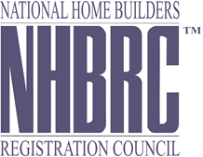

The National Home Builders Registration Council (NHBRC) hereby invite’s Prospective service providers to submit a bid for the following service:
BID ADVERT
Number | BID NUMBER | DESCRIPTION | Preference Point System | Non-Compulsory Briefing | Closing Date & Time
1 | NHBRC 36/ 2019 | REQUES FOR PROPOSALS: APPOINTMENT OF A PANEL OF CIVIL ENGINEERS FOR A PERIOD OF FIVE (5) YEARS  . | Not applicable Fixed Price | NHBRC Head Office, 25 February 2020 | 20 March 2020 At 11:00am

COLLECTION OF DOCUMENTS:
Bid documents are obtainable from NHBRC website (www.nhbrc.org.za/current-tenders)
Administration enquiries regarding specifications may be directed to:
Ms Paballo Relela at (011) 317 0144 / Mr Bernard Kekana at (011) 317 317 0114
E-mail: Tenders@nhbrc.org.za
CLOSING VENUE: All Bids must be placed in the tender box at the NHBRC Head Office: 27 Leeuwkop Road, Sunninghill, Johannesburg

