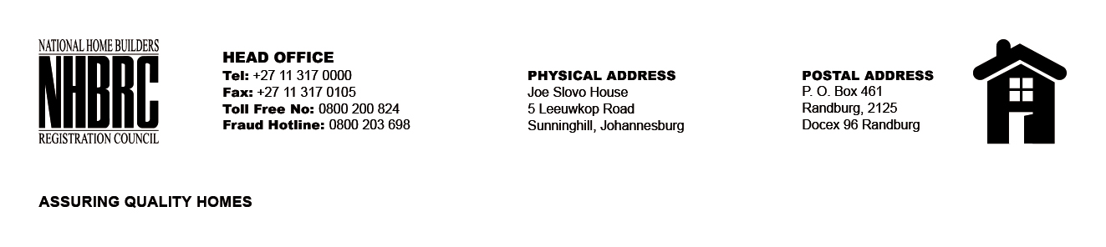

OPENING REGISTER
BID NUMBER : NHBRC 03/2023:
CLOSING DATE : 08 August 2023 @ 11H00

BID DESCRIPTION: APPOINTMENT OF A SERVICE PROVIDER TO PROVIDE
SUITABLE OFFICE ACCOMMODATION AND PARKING FACILITIES FOR THE PRETORIA
OFFICE FOR A LEASE PERIOD OF NINE (09) YEARS, ELEVEN (11) MONTHS

NO. | NAME OF BIDDERS | TOTAL BID PRICE (INCL. VAT)
1. | SKG Africa | R 18 871 623.90
2. | Mowana Properties | R 18 299 216.07
3. | SKG Africa | R 19 305 606.75
Total 03 Bids

