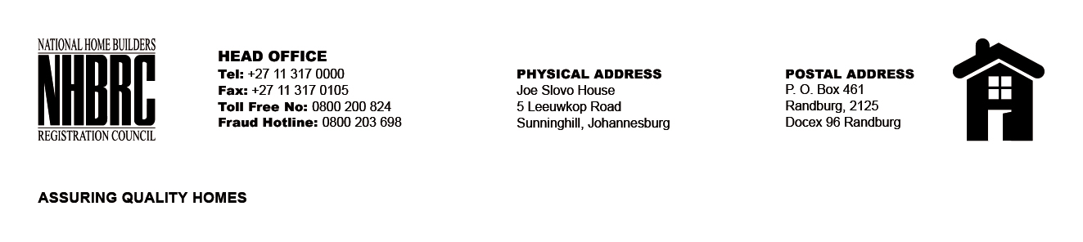

OPENING REGISTER

BID NUMBER : NHBRC 01/2023: CAPE TOWN
CLOSING DATE : 26 July 2023 @ 11H00

BID DESCRIPTION: APPOINTMENT TO THE NATIONAL HOME BUILDERS REGISTRATION COUNCIL’S (“NHBRC”) PANEL OF ATTORNEYS FOR A PERIOD OF FIVE (05) YEARS.

NO. | NAME OF BIDDERS
1. | MOSALA P. ATTORNEYS
2. | MAQUQA ATTORNEYS
3. | MOWZER TALIP ATTORNEYS
4. | MFINCI BAHLMAAN INC
5. | MALULEKE INC T/A MALUKS ATTORNEYS
6. | MOGASWA & ASSOCIATES INC
7. | MOKOLOBATE ATTORNEYS INC T/A INSTRUMENT ATTORNEY INC
8. | ROBERT CHARLES ATTORNEYS
9. | MJENXANE ATTORNEYS
10. | JONES ATTORNEYS
11. | ANDILE SETH ATTORNEYS
12. | ABRAHAMS & GROSS
13. | NONOZA POTELWA ATTORNEYS
14. | ENDERSTEIN MALUMBETE INC
15. | MAJANG AND ASSOCIATES INC
16. | COWAN - HARPER – MADIKIZELA
17. | PADI INCORPORATED ATTORNEYS
18. | SM VAKALISA INC
19. | MATHAPO MOSHIMANE MULANGAPHUMA T/A DM5 INC
20. | MADIBA MOTSAI MASIBENYANE & GITHIRI
21. | MACROBERT INCORPORATED
22. | BONGANI DYANI T/A BONGANI DYANI ATTORNEYS
23. | STRATFORD LEMBOE INC
Total 23 Bids

