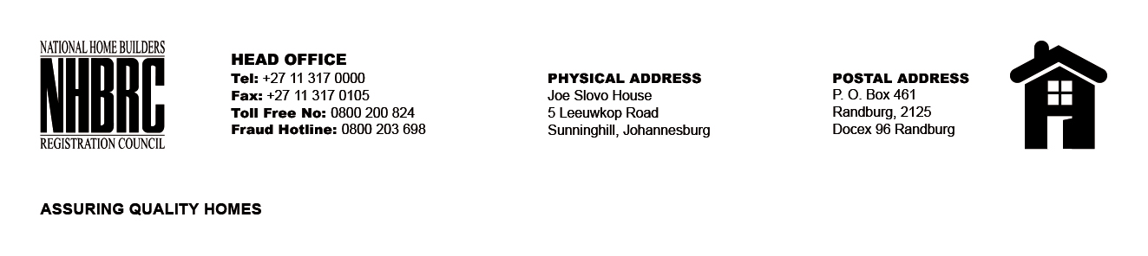

OPENING REGISTER

BID NUMBER : NHBRC 01/2023: LIMPOPO
CLOSING DATE : 21 July 2023 @ 11H00

BID DESCRIPTION: APPOINTMENT TO THE NATIONAL HOME BUILDERS REGISTRATION COUNCIL’S (“NHBRC”) PANEL OF ATTORNEYS FOR A PERIOD OF FIVE (05) YEARS.

NO. | NAME OF BIDDERS
1. | MAFA & ASSOCIATES INC
2. | MOHUBA INC ATTORNEYS
3. | BOQWANA BURNS & VIMBA AND ASSOCIATES
4. | MATABANE INCORPORATED
5. | MADIBA & CO ATTORNEYS
6. | RACHIDI EUGENE INC ATTORNEYS’ INC
7. | SPHIWE MILAZI INC ATTORNEYS
8. | ME KUAHO INC T/A KUAHO ATTORNEYS
9. | MACHABA INC ATTORNEYS
10. | MONTANI ATTORNEYS
11. | NYOFFU ATTORNEYS
12. | POPELA MAAKE INCORPORATED
13. | SENYATSI INC ATTORNEYS
14. | NKONWANA (PROFESSOR) ATTORNEYS INC
15. | MMP INCORPORATED MAKWELA MP ATTORNEYS
16. | VERVEEN ATTORNEYS
17. | MOLOKO PHOOKO ATTORNEYS
18. | ZAR ATTORNEYS
19. | FR CHAUKE INCORPORATE ATTORNEYS
20. | NJ MORERO INC
21. | NOBELA ATTORNEYS’ INC
22. | EVERTON DANKURU ATTORNEYS
23. | MABIBA MOTSAI MASITENYANE & GITHIRI ATTORNEYS
24. | MOGASWA & ASSOCIATES INC
25. | SM VAKALISA INC
26. | MALULEKE INC T/A MALUKS ATTORNEYS
27. | MOHALE INCORPORATED
28. | C MABUNDA INC
29. | KARABO WILLIAM LEDWABA ATTORNEYS’ INC
30. | TJ MOKOENE ATTORNEYS
Total 30 Bids

