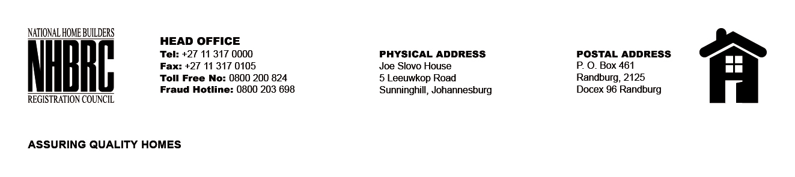

BID NUMBER: NHBRC 11/2023
CLOSING DATE: 02 FRBRUARY 2024 @ 11H00

BID DESCRIPTION: REQUEST FOR PROPOSALS: APPOINTMENT OF A PANEL OF SERVICE PROVIDERS TO PERFORM RESIDENTIAL INSPECTORATE ON BEHALF OF THE NHBRC FOR A PERIOD OF FIVE (5) YEARS
DURBAN- KZN

NO. | NAME OF BIDDER
1. | TRIAKON ENGINEERING (PTY) LTD
2. | MJT CONSULTING ENGINEERS
3. | JTP CONSORTIUM (PTY) LTD
4. | SERETO VENTURES CC
5. | KHULA SJABULE TRADING (PTY) LTD
6. | MBL MANUFACTURING
7. | NDLOVU NGONYAMA CONSULTING ENGINEERS
8. | LODEMANN PROJECTS (PTY) LTD
9. | PHUMULANIMAZWI TRADING (PTY) LTD
10. | THEMANE MANAGEMENT CONSULTING (PTY) LTD
11. | LIFE TIME PROJECTS AND TRADING (PTY) LTD
12. | ISISEKO ENGINEERS
13. | GUDUNKOMO INVESTMENTS AND CONSULTING (PTY) LTD
14. | E-SQUARE ENGINEERING (PTY) LTD
15. | SHAWENI CONSULTING ENGINEERS (PTY) LTD
16. | V3 CONSULTING ENGINEERS (PTY) LTD
17. | THEKWINI GEOCIVILS CC T/A TGC ENGINEERS
18. | 690 SIGNATURE GROUP
19. | ETILWENI (PTY) LTD
20. | UNDASA PROJECT PARTNERS
21. | KHUSI PROJECTS (PTY) LTD
22. | MGM NGWENYA CONSULTING ENGINEERS
23. | MAKHOSANA TRADING ENTERPRISES
24. | MDN WETHU
25. | TRUPA CORNER
26. | DISTANT STAR TRADING 164 CC
TOTAL:26

