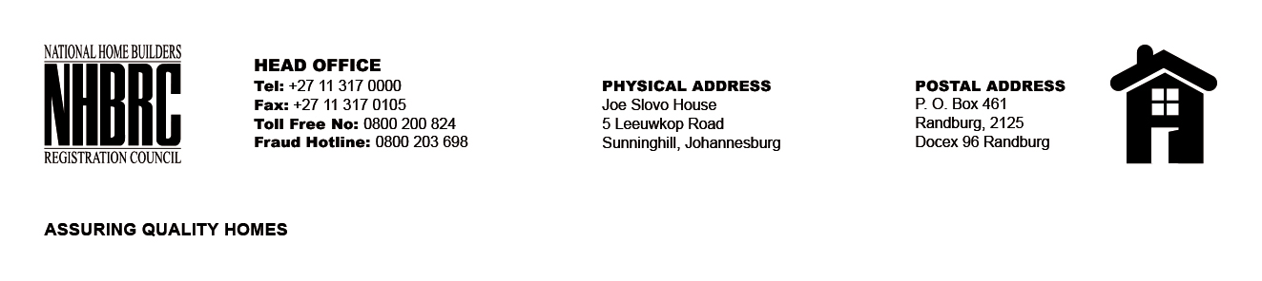

OPENING REGISTER

BID NUMBER : NHBRC 03/2023_Polokwane Office Lease Re-advert
CLOSING DATE : 01 February 2024 @ 11h00

BID DESCRIPTION: REQUEST FOR PROPOSALS: APPOINTMENT OF A SERVICE
PROVIDE TO PROVIDE SUITABLE OFFICE ACCOMMODATION AND PARKING
FACILITIES FOR THE POLOKWANE OFFICE FOR A LEASE PERIOD OF FIVE (05) YEARS.

NO. | NAME OF BIDDERS | PRICE (INCL. VAT)
1. | Talas Properties (Pietersburg cc) | R 12 301 734.23
2. | Lebombo Beleggings Pty Ltd | R 17 100 194.10
3. | Neom Properties (Pty) Ltd | R 13 358 250.39
TOTAL BIDS RECEIVED |  | 03

