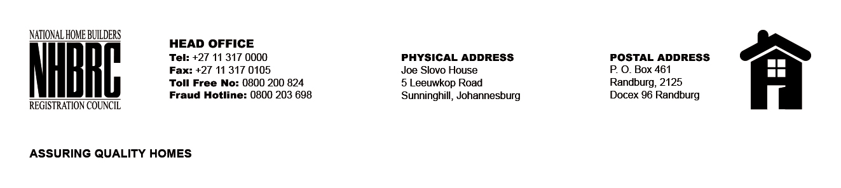

BID NUMBER: NHBRC 03/2023 NC RE- ADVERT 1
CLOSING DATE: 10 APRIL 2024 @ 11H00

BID DESCRIPTION: REQUEST FOR PROPOSALS: APPOINTMENT OF A SERVICE PROVIDER TO PROVIDE SUITABLE OFFICE ACCOMMODATION AND PARKING FACILITIES FOR THE NHBRC KIMBERLEY OFFICE FOR A LEASE PERIOD OF FIVE (05) YEARS.

NO. | NAME OF BIDDER | PRICE (INCL. VAT)
1. | DELTA PROPERTY FUND LIMITED | R1 437 345,06
TOTAL |  | 01

