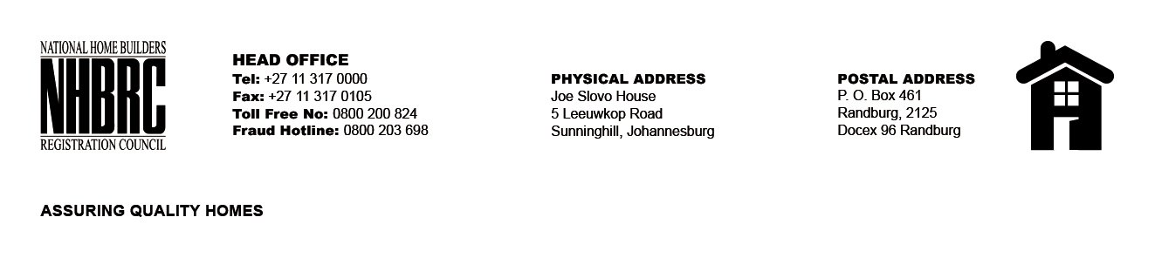

BID NUMBER: NHBRC 07/2024
CLOSING DATE: 15 NOVEMBER 2024 @ 11H00

BID DESCRIPTION: APPOINTMENT OF A SERVICE PROVIDER FOR THE PROVISIONING OF CLOUD-BASED BACKUP AND DISASTER RECOVERY (DR) TEMPORARY SERVICES FOR A PERIOD OF SIX (6) MONTHS

NO. | NAME OF BIDDER | PRICE
1. | BUSINESS CONNEXION (BCX) | R5 188 655.24
2. | CORE 2 EXTREME IT SOLUTION | R737 844.00
3. | OMNI AFRICA | R176 509.67
4. | IDOL CONSULTING FIRM | R1 308 935.22
5. | ARGANTIC | R839 478.26
6. | IOCO DIGITAL | R1 088 725.14
7. | AFROCENTRIC IP | R820 478.21
8. | BOTTOMLINE IT | R989 000,02
TOTAL: 08

