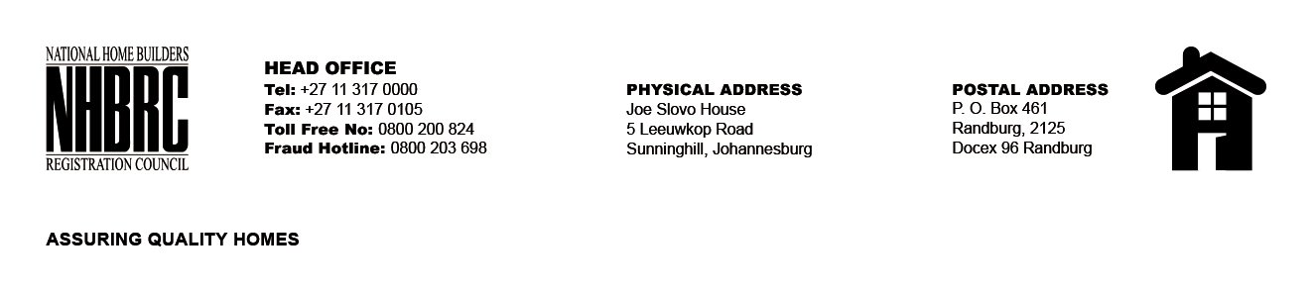

BID NUMBER: NHBRC 08/2024
CLOSING DATE: 02 December 2024 @ 11H00

BID DESCRIPTION: REQUEST FOR PROPOSALS: APPOINTMENT OF ADDITIONAL CONTRACTORS TO AN EXISTING PANEL OF CONTRACTORS FOR UNDERPINNING AND PILING (NATIONAL) FOR THE REMAINING 2 YEARS OF FIVE (05) YEARS PERIOD.

GAUTENG

NO. | NAME OF BIDDER
1. | TRIPLE WEAVE CONSTRUCTION & PROJECT
TOTAL: 01

