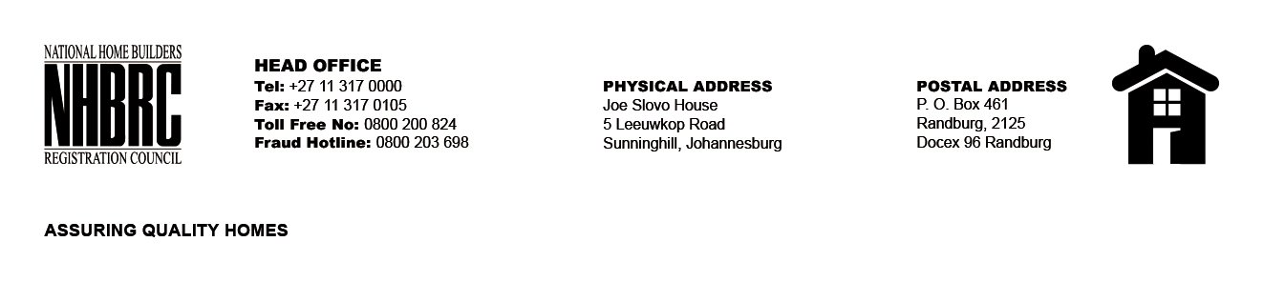

BID NUMBER: NHBRC 09/2024
CLOSING DATE: 03 December 2024 @ 11H00

BID DESCRIPTION: REQUEST FOR PROPOSALS: APPOINTMENT OF ADDITIONAL CONTRACTORS TO AN EXISTING PANEL OF CONTRACTORS SPECIALISING IN WATERPROOFING OF CONCRETE ROOF (NATIONAL) FOR THE REMAINING TWO (02) YEARS OF THE FIVE (05) YEAR PERIOD.

GAUTENG

NO. | NAME OF BIDDER
1. | MVELEDZISO TRADING AND PROJECTS
2. | AMAZING GRAZING
3. | TINTSWALO PROJECT MANAGERS
4. | PK CONSULTING GROUP CC
5. | NKHUMELEMORITA TRADING AND PROJECTS
6. | NDHLAMBILI’S CONSTRUCTION AND PROJECTS
7. | KWEN N TEE
8. | TUSHIYYAH HOLDINGS (PTY) LTD
9. | MATHELEMUSA TRADING AND PROJECTS
10. | SKHUTI PROJECTS
11. | AMAGUS KONSTRUKSIE BK
12. | MATSHEKETSHEKE CIVILS (PTY) LTD
13. | TSHIAMELO FOUNDATION (PTY) LTD
14. | CON-SOLVE CIVILS CC
15. | KENNY RONNY CONSULTING CC
16. | POSWA CONSTRUCTION (PTY) LTD
17. | KGALITSHEGO TRADING
18. | SHONTHOK TRADING JV MAGEZA SERVICES
19. | PIVOT PAINTING AND RENOVATION SOLUTIONS (PTY) LTD
20. | VZ BUSINESS OPERATIONS (PTY) LTD
21. | GAZELLO TRADING CC
TOTAL: 21

