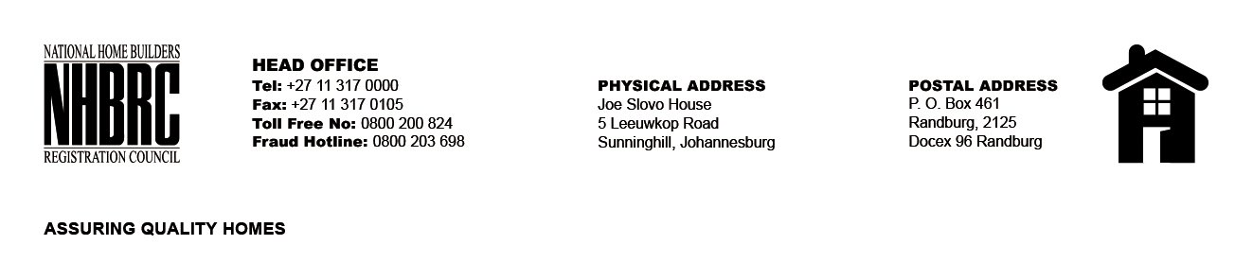

BID NUMBER: NHBRC 08/2024
CLOSING DATE: 12 December 2024 @ 11H00

BID DESCRIPTION: REQUEST FOR PROPOSALS: APPOINTMENT OF ADDITIONAL CONTRACTORS TO AN EXISTING PANEL OF CONTRACTORS FOR UNDERPINNING AND PILING (NATIONAL) FOR THE REMAINING 2 YEARS OF FIVE (05) YEARS PERIOD.

FREE STATE (BLOEMFONTEIN)

NO. | NAME OF BIDDER
1. | TRIPLE WEAVE CONSTRUCTION AND PROJECTS
TOTAL: 01

