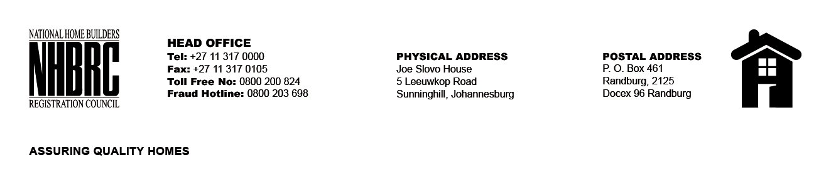

BID NUMBER: NHBRC 09/2024
CLOSING DATE: 10 December 2024 @ 11H00

BID DESCRIPTION: REQUEST FOR PROPOSALS: APPOINTMENT OF ADDITIONAL CONTRACTORS TO AN EXISTING PANEL OF CONTRACTORS SPECIALISING IN WATERPROOFING OF CONCRETE ROOF (NATIONAL) FOR THE REMAINING TWO (02) YEARS OF THE FIVE (05) YEAR PERIOD.

NORTHERN CAPE(KIMBERLEY)

NO. | NAME OF BIDDER
TOTAL: 0

