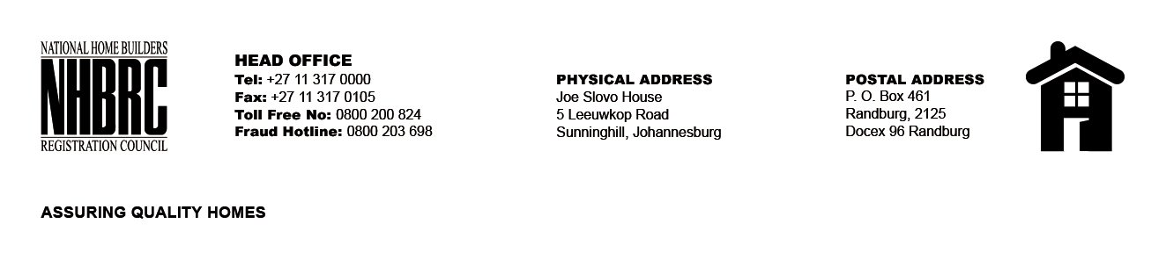

BID NUMBER: NHBRC 11/ 2024_NW MAHIKENG OFFICE
CLOSING DATE: 17 FEBRUARY 2025 @ 11H00

BID DESCRIPTION: REQUEST FOR PROPOSAL: APPOINTMENT OF A SERVICE PROVIDER TO PROVIDE SUITABLE OFFICE ACCOMMODATION AND PARKING FACILITIES FOR MAHIKENG OFFICE FOR A LEASE PERIOD OF FIVE (05) YEARS.

NO. | NAME OF BIDDER | PRICE
1. | AT AND T GROUP OF COMPANIES | R44 610 020.00
2. | COLUMBIA FALLS PROPERTIES 80 PTY LTD | R2 323 525.98
TOTAL: 02

