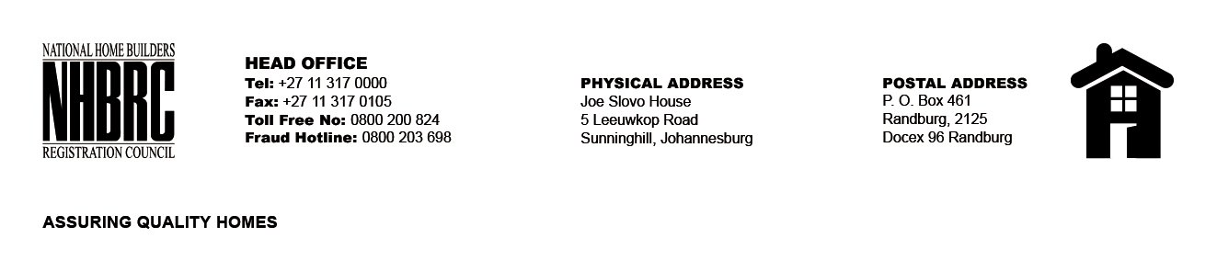

BID NUMBER: NHBRC 01/2025 LP
CLOSING DATE: 01 AUGUST 2025 @ 11H00

BID DESCRIPTION: REQUEST FOR PROPOSALS: APPOINTMENT OF A SERVICE PROVIDER TO PROVIDE SUITABLE OFFICE ACCOMMODATION AND PARKING FACILITIES FOR MODIMOLLE OFFICE FOR A LEASE PERIOD OF FIVE YEARS (05) YEARS

NO. | NAME OF BIDDER | PRICE
1. | HERIANUS (PTY) LTD | R 1 556 005.20
TOTAL: Three (01)

