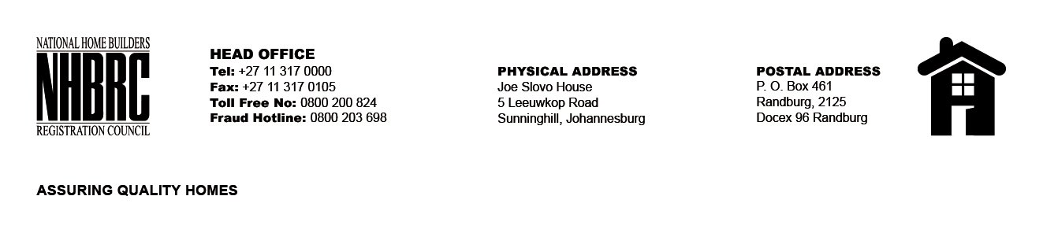

BID NUMBER: NHBRC 03/2025
CLOSING DATE: 04 AUGUST 2025 @ 11H00

BID DESCRIPTION: REQUEST FOR PROPOSALS: APPOINTMENT OF A SERVICE PROVIDER TO PROVIDE SUITABLE OFFICE ACCOMMODATION AND PARKING FACILITIES FOR RICHARDS BAY OFFICE FOR A LEASE PERIOD OF FIVE YEARS (05) YEARS

NO. | NAME OF BIDDER | PRICE
1. | GREENVILLE TRADING | R 4 132 961.71
2. | AAG PROJECTS | R 3 055 747.44
3. | ARROWGEM LIMITED | R 1 113 164.28
TOTAL: Three (03)

