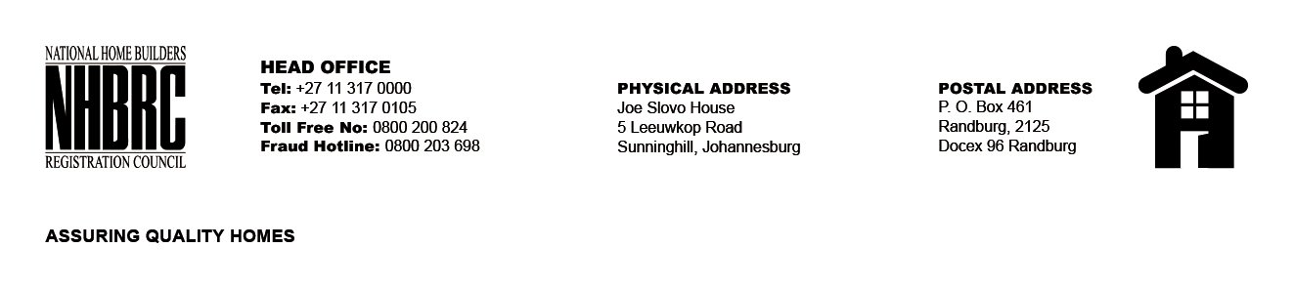

BID NUMBER: NHBRC 05/2025
CLOSING DATE: 17 SEPTEMBER 2025 @ 11H00

BID DESCRIPTION: REQUEST FOR PROPOSALS: APPOINTMENT OF A SUITABLE SERVICE PROVIDER FOR LEASE , SUPPLY, DELIVER AND MAINTENANCE INCLUDING WARRANTY OF RUGGED TABLETS FOR A PERIOD OF THREE (03) YEARS.

NO. | NAME OF BIDDER | PRICE
1. | SOLARIO TECHNOLOGIES | R 27 929 051.13
2. | PROVIDER BASE SOLUTION | R 10 695 000.00
3. | MABAPA TRADING T/A MAB TECHNOLOGIES | R 19 895 000.00
4. | NVOLVE SOLUTION | R 143 732.62 Per Unit
5. | DIGIT GROUP (PTY) LTD | R 66 343 394.62
TOTAL: 05

