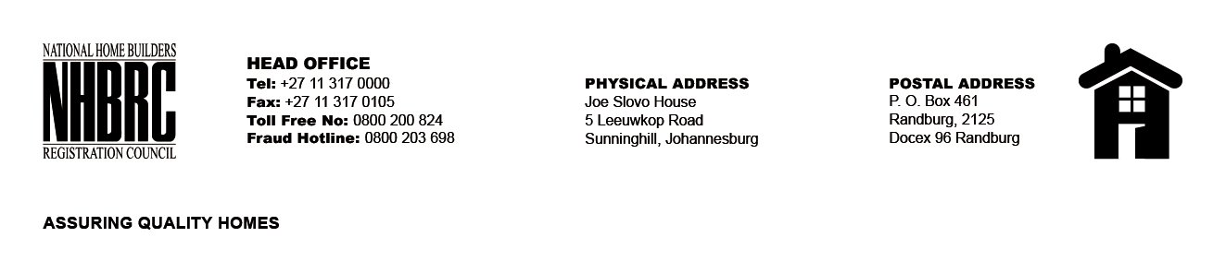

BID NUMBER: NHBRC 10/2025
CLOSING DATE: 26 JANUARY 2026 @ 11H00

BID DESCRIPTION: REQUEST FOR PROPOSALS: APPOINTMENT OF A PANEL OF FORENSIC INVESTIGATORS TO CONDUCT FORENSIC INVESTIGATIONS ON BEHALF OF THE NHBRC FOR A PERIOD OF THREE (03) YEARS (KZN- DURBAN)

NO. | NAME OF BIDDER | PRICE
1. | Abalandi Risk Management | N/A
2. | Mvula Enforcement Services | N/A
3. | Blitz Forensic (Pty) Ltd | N/A
4. | Itumeleng Tshatiwa and Associates | N/A
5. | Elidna Genesis Consulting Inc | N/A
6. | Ngubane Management Consultants | N/A
7. | SADL Consulting Services | N/A
8. | Morar Incorporated | N/A
9. | Mamatela Attorneys Inc | N/A
10. | Ernst & Young Advisory Services (Pty) Ltd | N/A
11 | SNG Grant Thornton
TOTAL: Eleven (11)

