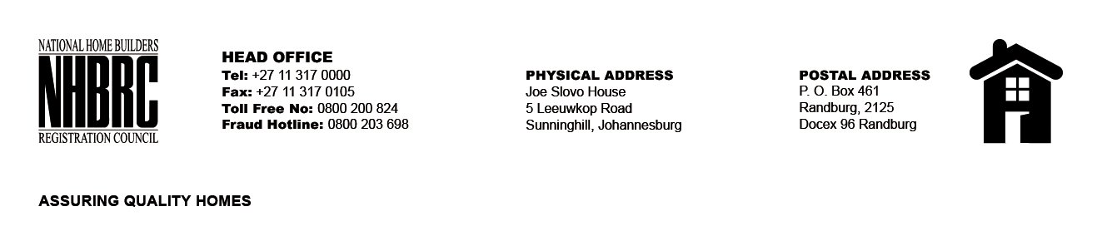

BID NUMBER: NHBRC 10/2025
CLOSING DATE: 19 JANUARY 2026 @ 11H00

BID DESCRIPTION: REQUEST FOR PROPOSALS: APPOINTMENT OF A PANEL OF FORENSIC INVESTIGATORS TO CONDUCT FORENSIC INVESTIGATIONS ON BEHALF OF THE NHBRC FOR A PERIOD OF THREE (03) YEARS

NO. | NAME OF BIDDER | PRICE
1. | PRO IUSTITIA FORENSIC (PTY) LTD | N/A
TOTAL: One (01)

