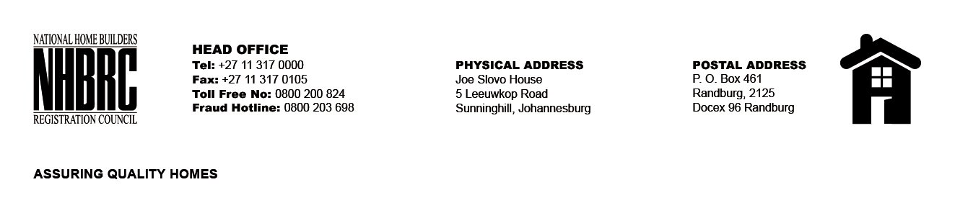

OPENING REGISTER

BID NUMBER : NHBRC 09/2025 KZN- DURBAN
CLOSING DATE : 27 January 2026 @ 11h00

BID DESCRIPTION: REQUEST FOR PROPOSALS: APPOINTMENT OF A PANEL OF RECORDING AND TRANSCRIBING SERVICE PROVIDERS FOR THE NATIONAL HOME BUILDING REGISTRATION COUNCIL (NHBRC) FOR A PERIOD OF (05) YEARS.

NO. | NAME OF BIDDERS | PRICE (INCL. VAT)
1. | Gauteng Ttranscribers CC | N/A
2. | Telabo Consulting (pty) Ltd | N/A
3. | Afrinet Communication | N/A
4. | Mkhatshwa Communication | N/A
5. | The Wing Group | N/A
TOTAL BIDS RECEIVED |  | 05

