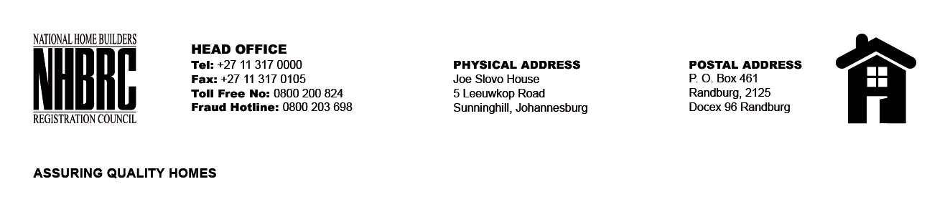

OPENING REGISTER

BID NUMBER : NHBRC 08/2026
CLOSING DATE: 09 October 2026 @ 11h00

BID DESCRIPTION: SUBJECT: REQUEST FOR PROPOSALS FOR THE APPOINTMENT OF SUITABLE QUALIFIED SERVICE PROVIDER TO PROVIDE MANAGED INFRASTRUCTURE SERVICES TO THE NHBRC FOR A PERIOD OF FIVE (05) YEARS

NO. | NAME OF BIDDERS | Price
 | Data Proof (MAAA0081559) | R 86 800 810,66
 | BOA Technologies (MAAAA0353871) | R 123 252 877.00
 | Pronet Technologies (MAA1553045) | R 126 914396.80
 | Business Connexion (BCX) (MAAA0001820) | R 111 399 359.68
 | Matlala Group (MAAA0947315) | R 47 038 833.59
 | Sonke Telecommunications (MAA0574526) | R 79 698 778.17
 | IOCO Infrastructure (MAAA0016510) | R 63 991 968.81
 | DigitCity (MAAA1071819) | R 6 914 396.80
 | Nkredible text (MAAA1702254_) | Price not mentioned
Total |  | 9

