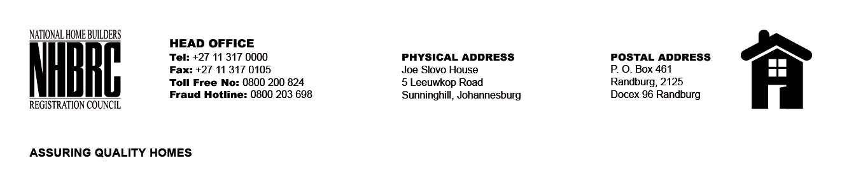

OPENING REGISTER

BID NUMBER : NHBRC 09/2026
CLOSING DATE: 23 OCTOBER 2026 @ 11h00

BID DESCRIPTION: REQUEST FOR PROPOSAL: APPOINTMENT OF A SERVICE PROVIDER FOR PHYSICAL GUARDING AND ARMED RESPONSE SECURITY SERVICE AT THREE (3) OFFICES OF THE NATIONAL HOME BUILDERS’ REGISTRATION COUNCIL IN GAUTENG FOR A PERIOD OF THREE (03) YEARS

NO. | NAME OF BIDDERS | MAAA Number
1. | Mosoni Security & Training | MAAA0040585
2. | Ever Vigilant & Security Services | MAAA0932030
3. | MMV Protection & Security Services | MAAA0238063
4. | Zabalaza General Business Enterprise | MAAA1382359
5. | Moriti | MAAA0656450
6. | Tikedi Holdings | MAAA6030777
7. | Prime Aprica Security Services | MAAA0083469
8. | Maximum Notions | MAAA0145770
9. | Lumkile Investments Holdings | MAAA0094243
10. | PT Wood Solutions Projects | MAAA0364130
11. | Mokondellelo Protection Services | MAAA0268022
12. | Selkrik Security Services Pty Ltd | MAAA0189846
13. | Jubzin Security Services | MAAA0011157
14. | Sinqobile Equestrian Security Services | MAAA096713
15. | Carewell Emergencies Ambulance | MAAA0278407
16. | Ingelosi Security Solutions | MAAA0318691
17. | JG Security & Construction | MAAA0964750
18. | Lephinda Cleaning & Security services | MAAA0196569
19. | AET Security Services | MAAA00202238
20. | NIST Investments | MAAA1294515
21. | Real Sec | MAAA0810054
22. | Marobele Security Solutions | MAAA0329256
23. | Mzansi Security & Training | MAAA0177642
24. | Songa Mbele Holdings | MAAA1094680
25. | Collins Sebola Financial services Pty Ltd | MAAA0027848
26. | Bahlokomele Security services | MAAA1569801
27. | Nkarabe Protection Services | MAAA0519501
28. | SecureLife Security Services | MAAA041419
29. | Dikgaetsedi Training & Projects | MAAA0079717
30. | Malope A Phahla Trading & Projects | MAAA0114310
31. | Lima Mike Security Services | MAAA0177653
32. | Thinkerpat Security Solutions | MAAA1078611
33. | MSG Security | MAAA0732654
34. | Calvin & Family Security Services | MAAA0333351
35. | Tamu Security | MAAA0862822
36. | Fullservce Services | MAAA0036733
37. | Vikelo Security | MAAA1518748
38. | Hwibidu Protection Services Pty Ltd | MAAA1710484
39. | Marumofase Security | MAAA0032370
40. | Nkhensi Carol Security Services | MAAA1426124
41. | LMB Security Services | MAAA0086978
42. | Mzansi Securityfire Group | MAAA1157813
43. | Mosa Security Services | MAAA1551730
44. | VS Security | MAAA1085325
45. | Military Risk Solutions Security | MAAA1014729
46. | Isilo Samabandla Projects | MAAA1749387
47. | GNG Trading Enterprise | MAAA0061425
48. | The Lady Boss Security Services | MAAA0033640
49. | Bonvinco Tactical Response | MAAA0084301
50. | Ram Protection Services | MAAA1514042
51. | Imvusa Trading 931 | MAAA0036707
52. | Ezingeni Security & Cleaning | MAAA0048195
53. | High Risk Protection & Investigation Services | MAAA0090974
54. | Mode Security | MAAA0000141
55. | Tsebane Tactical Response | MAAA1284010
56. | Tekana Security | MAAA0070392
57. | SMSS Security & Cleaning Services | MAAA0925168
58. | Fepana Protection Group | MAAA0848015
59. | Immediate Force Security | MAAA0593174
60. | Uyabonwa Security Services | MAAA0079259
61. | Mxo Crime Reduction Unit | MAAA0636287
62. | Maxiguard Security & Projects | MAAA0716726
63. | Silver Solutions 1522 | MAAA0071284
64. | Ndlexwork Protection | MAAA0695722
65. | Duncan Security | MAAA0520188
66. | GilaGila Protection Services | MAAA0324377
67. | Mufhatutshe Ozwa Protection Services | MAAA0064501
68. | Falcon Security Solutions | MAAA0328196
69. | Wenzile Phaphamu Security Services | MAAA0097726
70. | Oregon Projects | MAAA0694768
71. | TNI Superior General Trading (pty) ltd | MAAA0650850
72. | Theku Security Services | MAAA1100357
73. | Tincol Security Servieces | MAAA0826056
74. | Nast Protection Services | MAAA0483817
75. | Ndivhuwo Security Training | MAAA0014416
76. | Lemur Risk Solutions | MAAA0418353
77. | P.O.S Security Services | MAAA0398396
78. | Siyejabula Security Solutions | MAAA0064717
79. | Mmamphena Construction | MAAA0534632
80. | Lifeways Security Services | MAAA0911718
81. | Dephethogo Trading | MAAA0055357
82. | Royal Security | MAAA0010169
83. | Skonye Trading Enterprise | MAAA0094553
84. | MTSS | MAAA0598356
85. | Mamayila Trading Enterprise | MAAA0038615
86. | Eldna Security Services | MAAA0006655
87. | Takalani Security Holdings | MAAA1380665
88. | 7 Young Sisters Security & Projects | MAAA0008172
89. | CB Security Pty Ltd | MAAA0442701
90. | Inranite Security Solutions | MAAA0923831
91. | Lan Security Solutions | MAAA0079016
92. | Phuthadichaba Trading Enterprise | MAAA0107873
93. | Maanda-Nes-Investments | MAAA0003457
94. | Red Ant Security Relocation and Eviction Services | MAAA0085572
95. | Blueprint Associates | MAAA0397367
96. | Opinionated Business System Grey Security Services | MAAA1502587
97. | ICU Security | MAAA0730445
98. | Phalama Protection Services | MAAA1240412
99. | Idlangamandla Security Protection & Projects | MAAA0013245
100 | No Turning Back Trading Enterprise | MAAA0007585
TOTAL BIDS RECEIVED |  | 100

